1. A SedCloud can have four different ways to instantiate itself and Vms. Figure illustrates an activity diagram of the three possibilities.
- SedCloud with temporary VMs accoridng to solve requests
- SedCloud with persistent VMs according to the first solve request
- SedCloud with persistent Vms initiated at the same time
- SedCloud without any VM
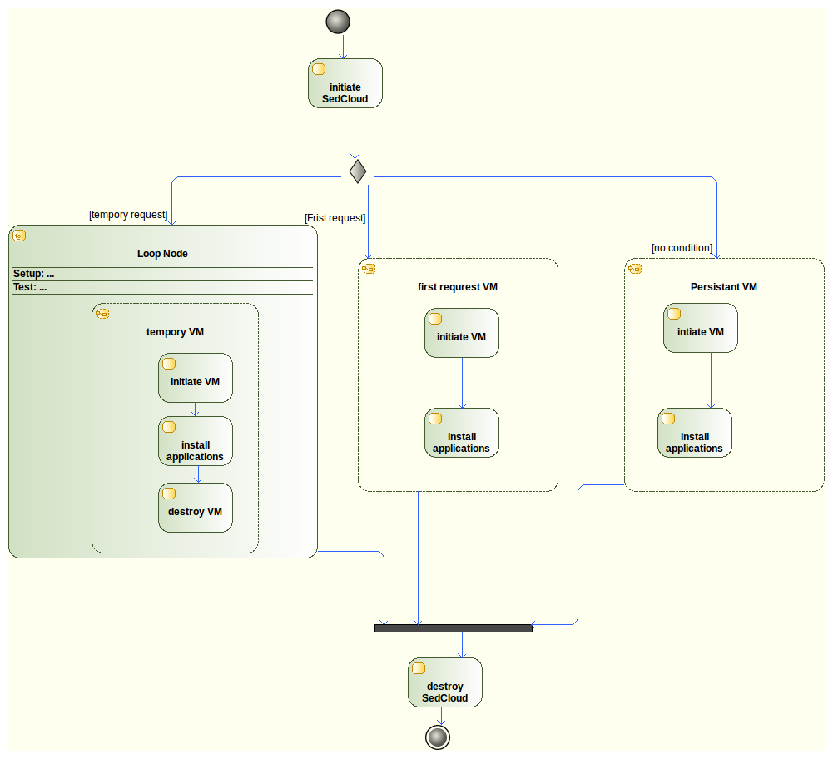

2. The simple diagram of SedCloud communication is presented in Figure.
- DeltaCloud is just used to instantiate or destroy a VM in cloud.
- The commnucation for applications at this moment is directly between SedCloud and Vms.
